TITLE TITLE ….
Ivanov L.V.¹, Petrova E.V.¹, Kuznetsov M.R.²
¹ Faculty of Soil Science, Moscow State University, Moscow, Russian Federation
² All-Russian Research Institute of Phytopathology, Bol'shie Vyazemy, Russian Federation
ivanov@mail.ru

Abstract: Abstract. (No more than 150 words)

Keywords: keywords… (no more than 5)

Introduction
A significant role….

Objects and Methods
The objects of the study were…

Results and Discussion
…. were detected in all studied samples.
According to the thermal conductivity formula…: (formulas must be provided in the Word constructor; symbols in the text are given in italics)
$$\frac{λ}{Δx}=\frac{1}{\frac{λ_{1}}{Δx_{1}}+…+\frac{λ_{n}}{Δx_{n}}}$$

The heat balance equation was written as F₁=cLV+F₂, where:
F₁ is the heat outflow through the snow cover and frozen ground from the freezing front (W/m2);
cLV is the heat flow.

(Table titles are given before the tables, figure titles after the figures)
Table 1. Granulometric composition of dark humus soil, %
Gorinonts | Fraction, %
Gorinonts | 1-0,25 | 0,25-0,05 | 0,05-0,01 | 0,01-0,005 | 0,005-0,001 | <0.001 | 0.01
10-20 | 0.7 | 12.4 | 36.6 | 17.1 | 28.1 | 5.1 | 50.3
30-40 | 3.9 | 6.0 | 27.6 | 18.4 | 36.4 | 7.7 | 62.5
50-60 | 3.1 | 6.8 | 29.3 | 18.6 | 34.3 | 7.9 | 60.8
70-80 | 0.5 | 3.2 | 23.3 | 20.5 | 43..9 | 8.6 | 73.0
80-90 | 0.6 | 4.9 | 27.8 | 19.5 | 40.1 | 7.1 | 66.7
90-100 | 0.2 | 4.5 | 32.7 | 19.9 | 36.8 | 5.9 | 62.6

Attention is drawn to...

Fig. 1. Aggregate composition (dry sifting, fraction content in %) (font size close to main text size, color)
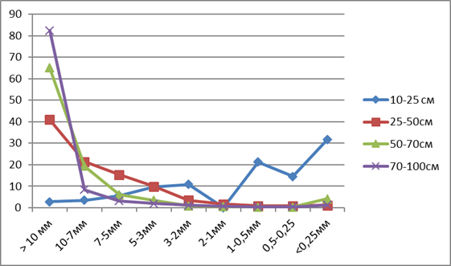

Conclusions
The characteristic features...

Acknowledgements
This work was supported by the topic of State Assignment GZ AAAA-... "Mapping...".

References (DOI, electronic links to the resource)
Balashova V.V. (1974) Mycoplasmas and Iron Bacteria. Moscow: Nauka, 65 p.
Vodyanitsky, Yu.N. (2010) Iron Hydroxides in Soils (Literature Review) // Pochvovedenie. No. 11. pp. 1341-1352 doi…
Methods of Soil Biochemistry and Microbiology. Ed. Zvyagintsev, D.G. // Moscow: Moscow University Press. 1991. 304 p.
Pinevich, A.V. (2005) Microbiology of Iron and Manganese. St. Petersburg University Press. 373 p. doi…
Molecular Probes, Inc. (1994). LIVE/DEAD BacLight bacterial viability kit (L 7012), instruction manual with appendix. Molecular Probes, Inc., Eugene, Oreg.
Panikov N. (2005) "Contribution of nanosized bacteria to the total biomass and activity of a soil microbial community" // Advances in Applied Microbiology. Vol. 57. Pp. 245-296.
Specialized datasets of climate research http://aisori.meteo.ru/ClimateR (date accessed xx.xx.xxxx)

File size and formatting requirements
The article must be submitted in DOCX format in accordance with the attached template. All formatting elements (section structure, heading fonts, table and figure caption style, reference list formatting) must be retained unchanged. The article must be up to 10 pages long, including figures, tables, abstracts, and reference list. Page margins are standard (top, bottom, left, and right – 2 cm each), the text is left-aligned, there is no indentation, and line spacing is single.
Main text: Times New Roman, 13 pt.
Article title: Times New Roman, 14 pt, bold, capital letters.
Section titles (Introduction, Objects and Methods, etc.): Times New Roman, 13 pt, bold, capital letters first.

