Synthesis of CuO/CeO₂ nanocomposites via solution combustion method and their catalytic activity in n-hexane conversion
Cam T.S.,¹ Popkov V.I.²
Aspirant, 2 course
¹Saint-Petersburg State Institute of Technology, Saint Petersburg, Russia
²Ioffe Institute, Saint Petersburg, Russia
E–mail: camthanhson1108@gmail.com
Solution combustion synthesis (SCS) has become a popular method to produce oxides or composites with nanoscale structure, large surface area. By the purpose of researching an economic-effective catalyst to use in petroleum refineries, we recommend three catalysts copper dioxide (CuO), cerium(IV) oxide (CeO₂) and their composite (0.5CuO/0.5CeO₂) synthesized by SCS method. The synthesized samples were characterized by a combination of physicochemical analysis – energy-dispersive X-ray analysis (EDXA), X-ray diffraction (XRD), scanning electron microscopy (SEM), N₂ adsorption-desorption isotherms and their catalytic activity was tested in n-hexane conversion.
The catalysts were synthesized according to the following reactions:
6Ce(NO₃)₃ + 14CO(NH₂)₂ = 6CeO₂ + 14CO₂↑ + 23N₂↑ + 28H₂O↑, | (1)
3Cu(NO₃)₂ + 5CO(NH₂)₂ = 3CuO + 5CO₂↑ + 8N₂↑ + 10H₂O↑, | (2)
2Ce(NO₃)₃ + 2Cu(NO₃)₂ + 8CO(NH₂)₂ = 2(CeO₂/CuO) + 8CO₂↑ + 13N₂↑ + 16H₂O↑. | (3)
EDXA results show the purity of three synthesized catalysts, as evidenced by the presence of 3 elements Ce, Cu, and O in the EDX spectra. SEM micrographs obtained exhibit a uniform, sponge-like morphology, and micron-sized agglomerated structure of all samples.
XRD results confirm that all the diffraction peaks of the synthesized samples match well with the Powder Diffraction Standards (JCPDS) of cerium and copper oxides. The average crystallite size () of the obtained substances was calculated using Scherrer’s equation with a deviation of D±2 nm, results are presented in Table 1.
The N₂ adsorption-desorption isotherms of the CeO₂, CuO, and 0.5CuO/0.5CeO₂ catalysts display type IV curves (according to the IUPAC classification of adsorption isotherms), which are characteristic of adsorbents that are mesoporous materials. The specific surface area ¹ and total volume in pores ² of the catalysts were measured and showed in Table 1.
The catalytic activity of the synthesized catalysts was performed in n-hexane conversion model reaction at 500°C and 1 atm, the experimental results (Figure 1) are compared with those of commercially available catalysts for zeolite catalytic cracking catalyst SiO₂/Al₂O₃=50 (ZSM-5) and Pt-containing paraffin dehydrogenation catalyst (CD-1). The synthesized samples show the highest activity in the isomerization reactions, which manifests itself in an increased content of isohexanes. The CeO₂ catalyst is characterized by the highest conversion of n-hexane of 35.4%, while for the CuO and CeO₂/CuO catalysts is 3.4 and 4.9% respectively.
The observed catalytic activity is interested in terms of the synthesis of materials that allow the isomerization of high-boiling hydrocarbon fractions in order to reduce the pour point and/or improve the viscosity characteristics.
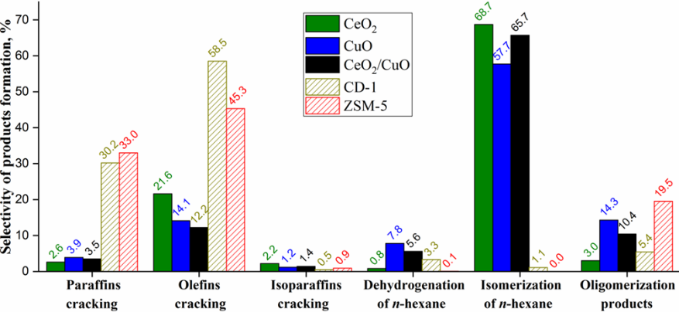
Table 1. Characteristics of synthesized catalysts
Catalyst | nmª | nmª | m²/g^{b} | cm³/g^{c}
CuO | 20.8 | − | 0.2 | 4·10⁻⁴
CeO₂ | − | 9.6 | 85.8 | 0.045
0.5CuO/  0.5CeO₂ | 19.6 | 4.2 | 46.0 | 0.021
ª Average crystallite size;
^{b} Specific surface area;
^{c} Total volume in pores;
¹ BET – Brunauer-Emmett-Teller method; Figure 1. Catalytic activity of the CuO, CeO₂, and 0.5CuO/0.5CeO₂
² DFT – Density Functional theory. catalysts in n-hexane conversion.

