Theoretical investigation of the optical properties of high-contrast phase structures inscripted by femtosecond laser radiation in lithium niobophosphate glasses
Kurushkin M.V.¹, Markov V.A.^{1,2}
Post-graduate
¹St. Petersburg State Polytechnical University, St. Petersburg, Russian Federation
²LLC “AtomTiazhMash”
E-mail: mkurushkin@spbstu.ru

Optical coherence tomography (OCT) is a modern, non-intrusive medical imaging technique particularly demanded for cancer diagnostics and retina scanning. Due to optical coherent tomograph having a micrometer resolution, reliable high-contrast 3D calibrating elements are required. Until the present research, calibrating elements with refractive index contrast 10⁻⁴ have been reported [2], which is insufficient for precise characterization of the tomograph’s performance. The goal of the present research is the use of femtosecond radiation for laser inscription of gradient phase structures in alkaline niobophosphate glasses to induce migration of alkaline metal cations to further enhance the refractive index contrast.
Lithium niobophospate glass of 50Li₂O-40P₂O₅-10Nb₂O₅ composition has been used for laser inscription. Laser radiation has induced the formation of regular phase structures in the volume of the glass. Scanning electron microscopy (SEM) photograph of the cross-section of the said structure is shown in Fig. 1.
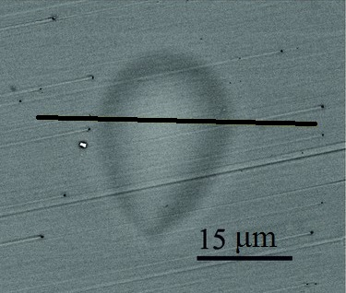
Fig. 1. SEM photograph of the cross-section of the inscripted phase structure.

Energy dispersive X-ray microanalysis (EDXMA) has been performed along the line in Fig. 1 to investigate the difference in elemental composition between the center and the edge of the structure caused by the laser-induced migration of lithium ions. The refractive index at the center and at the edge of the structure has been calculated based on the principle of additivity of ionic (Li, Nb) and covalent refractions (P, O) [1] according to Lorentz–Lorenz equation:
,
where R is the refraction, M is the molar mass, d is the density and n is the refractive index.
The obtained refractive indices are 1.45 for the center and 1.43 for the edge of the structure. The resulting difference between the refractive indices (10⁻²) is ascribed to the migration of lithium ions towards the edge of the structure and the increase in niobium content at its center. The achieved difference in refractive index makes lithium niobophosphate glass a promising material for the production of high-contrast 3D calibrating elements.

The work is financially supported by government grant # 14.576.21.0003.

References
1. Batsanov S. S. Structural refractometry. Moscow: Vyshshaya shkola. 1976.
2. Tomlins P.H., Smith G.N, Wooliams, P.D., Rasakanthan R., Sugden K. Femtosecond laser micro-inscription of optical coherence tomography resolution test artifact // Biomed Opt Express. 2011, Vol. 2(5).

