Business cycles fluctuations in European Union
Kochetkova Diana Vladlenovna
student
Financial University under the government of Russian Frderation ,
International Financial Faculty, Moscow, Russia
E–mail: kochetkova.diana@mail.ru

Business cycles fluctuations belong to the history of modern economies with interdependent markets, free enterprises and private ownership of financial assets and capital goods. Business cycles have undergone a booming development in the era of significant growth of industry, banking and credit.
In this work the attention is put to European Union (EU) business cycles.
The aim of this research is to statistically prove the existence of a European business cycle and to notice that sometimes countries move in the opposite directions. It can be done through the study of some classical indicators, such as GDP (real, nominal), rate of inflation, rate of unemployment and etc. Also we can express the relations between countries business fluctuations by using some correlation coefficients.
The synchronization of business cycles is usually measured by using GDP and industrial production. But, these variables do not show in full manner the ratio of trade and exchanges between countries that help to regulate business cycles and lead to synchronization. Taking it into consideration it becomes necessary to study the annual changes in imports and exports together with GDP changes.
The analysis is based on the annual data over the period 1991-2011, for a sample of 27 countries from Europe, 23 members of the EU and 4 non-members, taken from Bloomberg and World Bank database, together with aggregated data for the Euro area obtained from the same sources.
The countries are divided into 5 groups: EU founding member states, ”second wave” countries, ”third wave”, ”forth wave” and non-EU states. With the help of Bloomberg and World Bank I have obtained the data about GDP’s, rate of export and import of countries which are observed in my research. Then with help of SPSS this data was transformed into correlation coefficients and was put in logical order (in terms of levels of synchronization) and finally represented in graphs for better visual understanding.
Firstly was considered synchronization according to GDP. Figure 1 shows the correlations between the Euro area aggregate GDP changes and the other countries. The founding members and the second wave adhering countries are strongly and very strongly correlated with the Euro area business cycle according to the annual GDP growth.
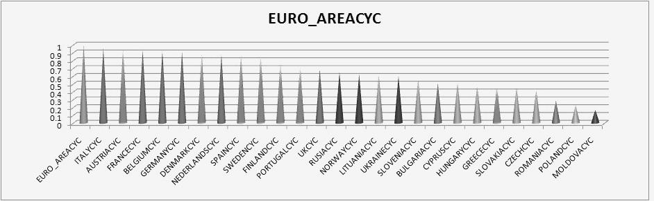
Figure 1 - Euro area business cycle synchronization (%)
UK shows rather unusual behaviour, and maintains only a medium synchronization, in comparison to the non-EU members. This medium synchronization group also includes most third wave adhering countries and Bulgaria, scoring a 51% syncronization with the Euro-area although it belongs to the fourth wave.
Romania (28%) and Poland (22%) are the most weakly synchronized countries of the EU, followed only by also former soviet-bloc member, Moldova (16%).
In the current context, economic integration of countries in a certain area is a viable solution to combat and overcome the problems caused by adverse economic or social crisis. But as any phenomenon of this kind, it will have negative effects.
Besides the advantages created by an area of economic cooperation, the common legal, commercial and administrative vision draws on a number of disadvantages. One of those disadvantages is the transmission of economic shocks from one country to another by synchronization of the business cycles having the same nature.
During the research it was proved that the Euro area has a clearly defined business cycle dictated by the founding members and the second wave countries. Third and fourth waves countries display a medium, respectively a low synchronization, which is due to differences in currency, technology and lack of political integration.
The European Union is a macroeconomic organism which begins to display self regulating functions but is still far from being a perfectly smooth machinery.

Literature
- Barrios S, Brülhart M, Elliot R, Sensier M (2002) A tale of two cycles : co-fluctuations between UK regions and the Euro Zone. Centre for Growth and Business Cycle Research (University of Manchester), Discussion Paper No. 003.
- Harding D, and Pagan A. (2002), Dissecting the Cycle: a Methodological Investigation, Journal of Monetary Economics
- Wynne A. M. and J. Koo (2000), Business Cycles under Monetary Union: A Comparison of the EU and US, Economica.
- http://www.worldbank.org/ (World Bank)
- http://www.bloomberg.com/ (Bloomberg)

