Synthesis of cyclohexadienyl ruthenium complexes
Loskutova N.L.
Student
A.N. Nesmeyanov Institute of Organoelement Compounds
of Russian Academy of Sciences, Moscow, Russia
loskutovanl@gmail.com

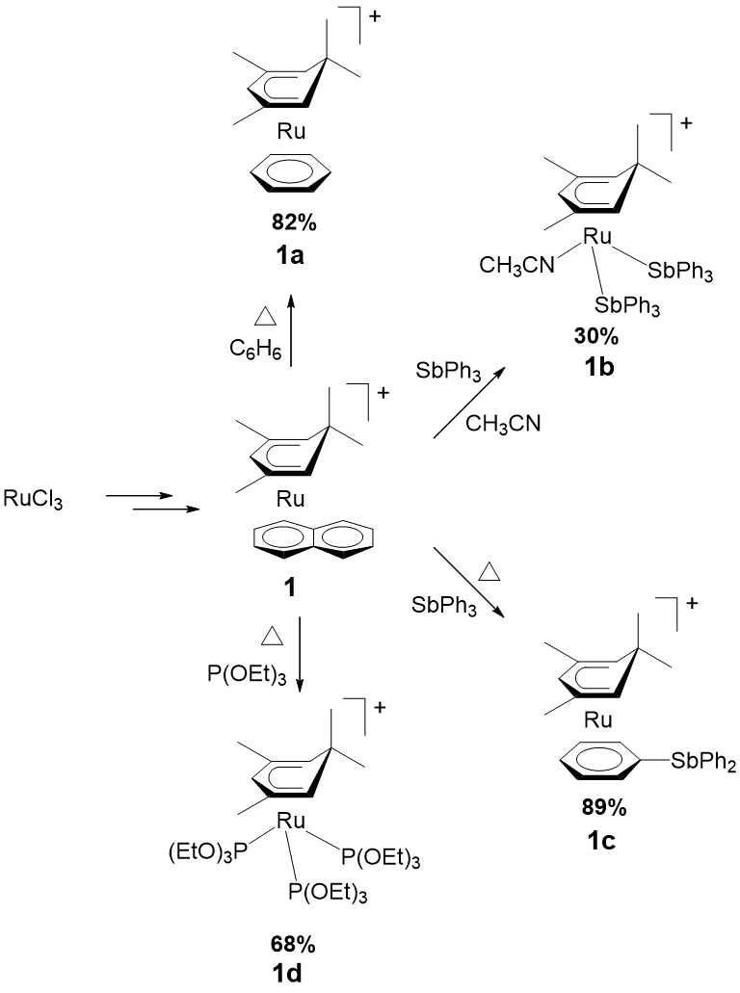
Cyclopentadienyl ruthenium complexes with labile ligands are widely used in organometallic synthesis and catalysis. However, little is known about their cyclohexadienyl analogues.
Therefore the aim of this research was to synthesize [(η⁵-(CH₃)₄C₆H₃)Ru(C₁₀H₈)]⁺ complex 1 and to investigate its activity in reactions of naphthalene ligand’s substitution.
It was shown that complex 1 can be obtained from readily available RuCl₃ in two stages. A number of ligands with different denticity was tried in subsequent naphthalene substitution reaction. Some examples 1a-d are represented in the scheme.
It is noteworthy that SbPh₃ ligand can coordinate to ruthenium center either as σ-donor or as π-donor depending on the reaction conditions. Adding of SbPh₃ and acetonitrile to the starting material 1 results in the 1b formation, while the reflux of complex 1 with SbPh₃ in acetone affords 1c as a product.

Literature

- Bauer A., Englert U., Geyser S., Podewils F., and Salzer A. Organometallics 2000, 19, 5471-5476.
- Dimauro P.T. and Wolczanski P.T. Polyhedron 1995, 14, 149-165.
- Gill T.P. and Mann K.R. Organometallics 1982, 1, 485-488.

