SYNTHESIS AND INVESTIGATION OF Transport Properties of HYBRID MATERIALS based on NAFION MEMBRANE, DOPED BY SiO₂ AND M_{x}H_{3-x}PW₁₂O₄₀ (M – K, Rb, Cs)
Prikhno I.A.
Student
Kurnakov Institute of general and inorganic chemistry of Russian Academy of Sciences, Moscow, Russia
ivan_prikhno@russia.ru

Perfluorinated cation-exchange Nafion-type membranes are widely used in such spheres of industrial and scientific activities as electrochemical synthesis, water purification and development of low-temperature fuel cells which are considered to be ecologically pure energy source. To improve such membrane properties as conductivity and water uptake an approach is used to modify them with inorganic dopants. Today crystal hydrates of phosphotungstic heteropolyacid (PWA) are considered to be one of the most highly conducting inorganic compounds. But because of its high solubility one should stabilize it to use as dopant in membrane, e.g. by sorption on surface of SiO₂ and by conversion of it into low- and non-soluble acid salts of alkaline metals.
The aim of this work was to synthesize Nafion membranes, which are modified by silica, PWA and its acid salts of potassium, rubidium and caesium, and to investigate its transport properties. Nafion 117 membranes were modified by in situ method (by introduction of dopant into matrix of prepared membrane). TEM data show that hybrid materials contain nanoparticles of 3 - 5 nm size. Elemental analysis data show that membranes contain about 1 wt. % of SiO₂ and ~2 wt. % of PWA and its salts. Membrane modification leads to increase in water uptake by 2-3 % compared with initial Nafion and to considerable increase in ionic conductivity especially at low relative humidity. Materials containing low-soluble acid salts of PWA have lower conductivity than material containing PWA, but are more stable (left figure). It is determined that diffusion permeability of HCl solution in Nafion+SiO₂+M_{x}H_{3-x}PW₁₂O₄₀ systems is lower, than in Nafion+SiO₂ and additionally decreases with increase of cation’s ionic radius. The reason of decrease in diffusion permeability is that formation of second Debye layer on the surface of dopant due to the PWA salts dissociation prevents diffusion of anions through membrane (right figure).
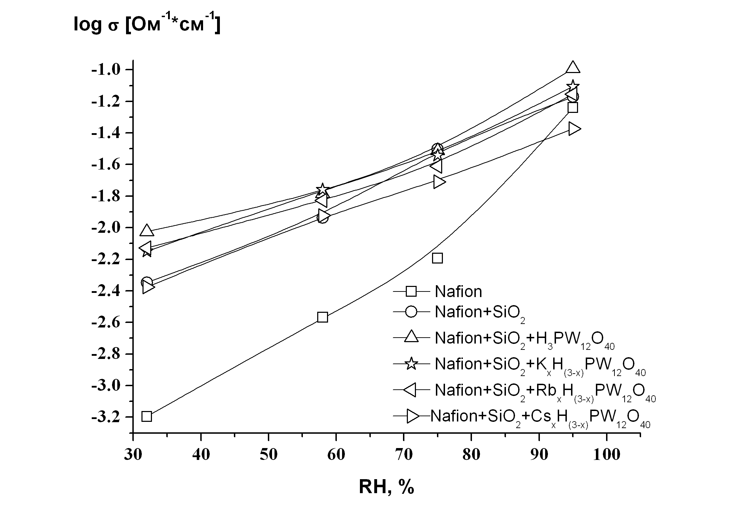 | 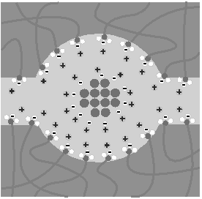
Relative humidity dependence of proton conductivity. | A scheme of the pore in hybrid membrane containing acid salts of PWA.

